2024

netstrata

User Interface proposal

The AVIT Group | 105A Vanessa Street, Sydney New South Wales 2208

|  |  |  |  |
| --- | --- | --- | --- |
| **Version** | **Date** | **Author** | **Notes** |
| 1.0 | 4/7/2024 | Rod Driscoll | Initial version |

Contents

Introduction 2

Spaces with local touch screens 2

Spaces with input detection 2

Digital signage displays 2

Site wide schedule control 3

Local remote-controlled display 3

Background music 3

Combinable multi-purpose 4

Start page 5

Power 6

Link Rooms 7

Presentation mode 8

Footer menu 8

Video sources 9

Audio Levels 9

Cameras 10

Recording 10

Displays 11

Volume control 11

Stand-alone multi-purpose room 12

10-person meeting room 13

# Introduction

This document contains details of the audiovisual user interface design for the project:

Netstrata

280-298 Railway Parade,

Carlton NSW

The project shall be completed by:

The AVIT Group

105A Vanessa Street,

Sydney NSW 2208

The project shall contain Crestron control systems with several touch panels.

The AV (audiovisual) system shall be used for audio and video source selection and volume control throughout the facility.

## Spaces with local touch screens

These spaces shall be configured with display power, source selection and volume control via a touch panel located in the room.

|  |  |
| --- | --- |
| **Room Name** | **Lvl** |
| Combinable Multi-purpose | Gnd |
| Standalone multipurpose | Gnd |
| 10p Meeting | 3 |

## Spaces with input detection

These spaces shall be configured to have the display power when a PC is connected to the display.

|  |  |
| --- | --- |
| **Room Name** | **Lvl** |
| 6P Meeting x 3 | Gnd |
| Open meeting space | 3 |
| 4P Meeting x 2 | 3 |
| 17P Meeting room | 4 |
| Project space 1 | 4 |
| Open meeting space | 4 |
| 4P Meeting | 4 |

## Digital signage displays

Digital signage displays shall be configured to power on and off at scheduled times.

|  |  |
| --- | --- |
| **Room Name** | **Lvl** |
| Digital signage | 3 |
| Digital signage | 4 |

## Site wide schedule control

A touch panel in the lobby shall be used to configure schedule times for power of all display and meeting spaces in the facility.

|  |  |
| --- | --- |
| **Room Name** | **Lvl** |
| Lobby | Gnd |

## Local remote-controlled display

A display in the staff hub shall be controllable with the generic remote control for free to air television.

|  |  |
| --- | --- |
| **Room Name** | **Lvl** |
| Staff hub | 4 |

## Background music

A local touch panel shall be used for volume control and audio source selection in the terrace. Audio sources shall be a Bluetooth input and streaming radio.

|  |  |
| --- | --- |
| **Room Name** | **Lvl** |
| Terrace | Roof |

# Combinable multi-purpose

A touch panel in each room controls the audiovisual system for the spaces.

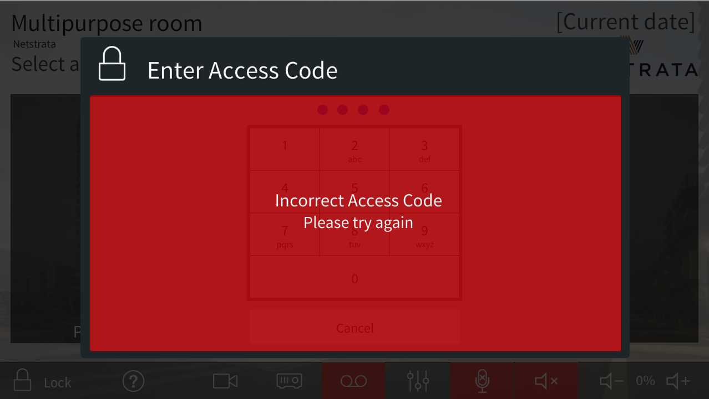

Figure 1: PIN keypad.

All touch panels can be locked by pressing the padlock icon to the bottom left of the touch panel, to unlock the panel a PIN will need to be entered.

The main buttons will be coloured grey when not selected and blue when selected (e.g. when the system is on)

## Start page

The start page will be visible when the system is idle.

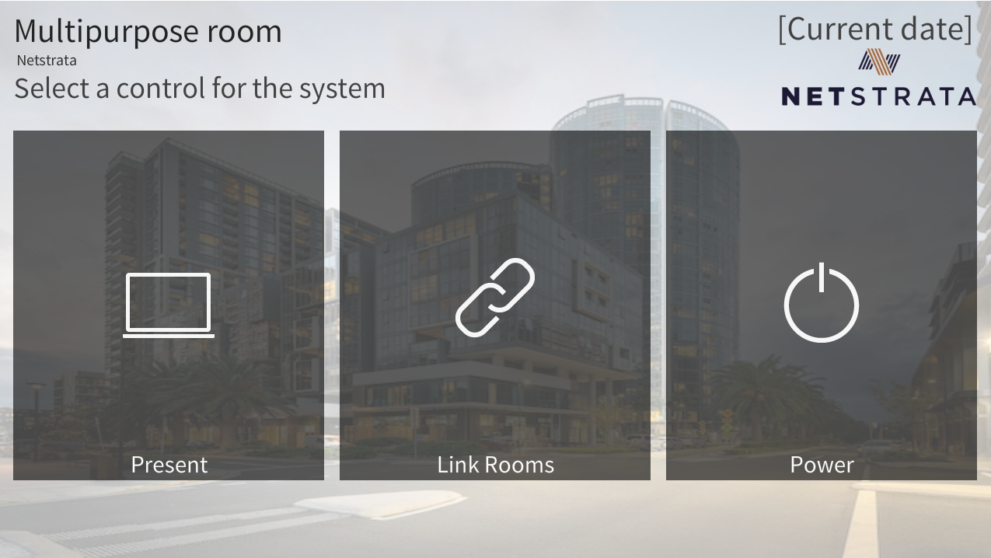

Figure 2: Start page

Pressing “**Power**” will perform the following actions:

* Power the system on if it was off, or if the system is on it will display the power confirmation page.

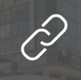

Pressing “**Link Rooms**” on either the main menu or the bottom menu bar will cause the Link Rooms page to appear.

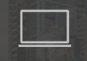

Pressing “**Present**” on the main menu will cause the following:

1. Audio in the room will become un-muted, allowing microphones to work
2. The touch panel will display the available presentation sources and a footer bar with room control options.

## Power

Figure 3: Power off confirmation.

Powering the system on will perform the following actions:

* Recall an audio preset to set all audio levels to default.
* Display the footer menu on the user interface.

Powering the system off will perform the following actions:

* Power off the display.
* Raise the motorised screen (if the room contains a motorised screen).
* Clear all audio and video routes in the room.

## Link Rooms

Figure 4: Link Rooms page

There are three linked room configurations to choose from:

1. Unlink
   1. each room will be standalone, using the LED screen as the video source for each room.
2. Link Rooms
   1. The LED screens in both rooms will display content, mirroring each other
   2. Room 2 will become the master room, selecting a presentation source will cause the source for room 2 to be presented in both rooms.
   3. The audio in both rooms will be the same, including volume levels.
   4. Microphones for both rooms will be available.
3. Town Hall
   1. Room 2 will become the master room, selecting a presentation source will cause the source for room 2 to be presented on the projector.
   2. The LED screens in both rooms will power off.
   3. The audio in both rooms will be the same, including volume levels.
   4. Microphones for both rooms will be available.

## Presentation mode

When the system is powered on the footer menu will be visible.

Figure 5: Presentation page

### Footer menu

 Press “panel **lock**” to lock the user interface and show the PIN page.

Press “**help**” to display a help page with contact details for technical support.

Press “**room link**” to display the room combining page.

When the rooms are combined the button will be dark grey.



Press “**camera**” to display the camera page.

Press “**projector**” to display the room display page, which includes screen control.

When the room display is on the button will be dark grey.



Press “**record**” to display the recording page.

When recording is active the button will be red.



Press “**levels**” to display the audio levels, such as microphones.

Press “**privacy**” to mute all microphones in the room.

When all microphones are muted the button will be red.

Press “**speaker** **mute**” to mute to mute the speakers in the room.

When the speakers are muted the button will be red.



Press “**volume**” controls to adjust volume of the speakers in the room.

### Video sources

Press a “**video source**” to turn on the room display and route that source to the display. When a video source is selected the button will be blue.

## Audio Levels

Figure 6: Level controls

All necessary volume and mute controls will be displayed on this page for adjustment.

The exact volume controls to be on this page will be determined as the system is configured.

## Cameras

Camera controls will be on this page. The names and quantity of camera buttons will match the cameras available in the room.

Figure 7: Camera page

## Recording

Recording controls will be on this page. The current video source will be recorded.

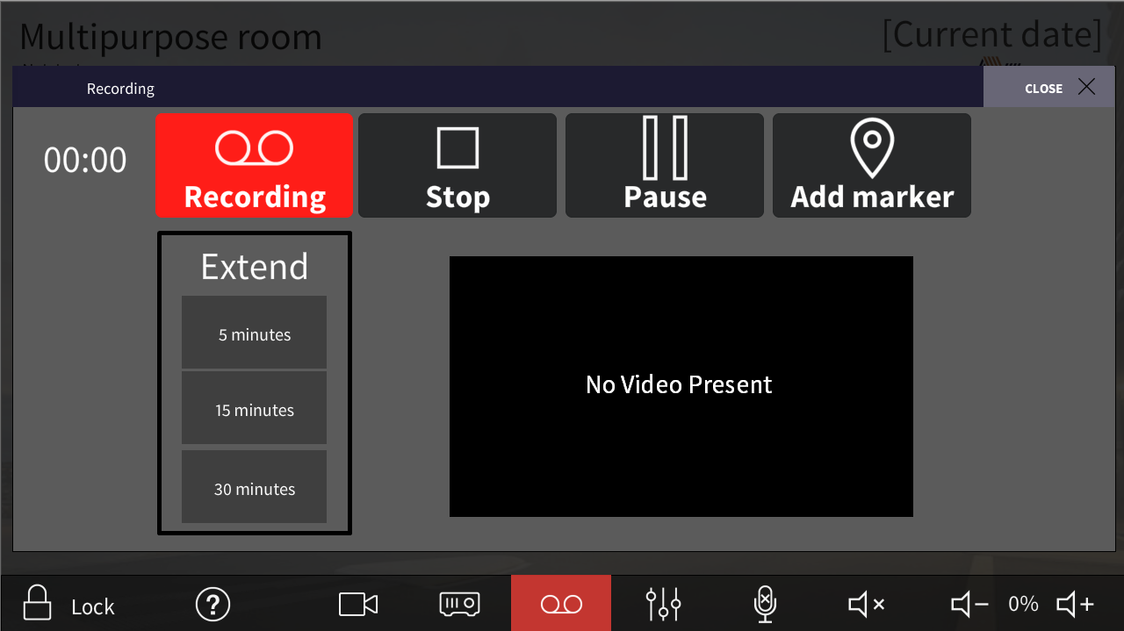

Figure 8: Recording page

## Displays

Display control will be on this page. The projector, screen and lift control will only be present in room 2. Video preview will be available if supported by the devices in the room.

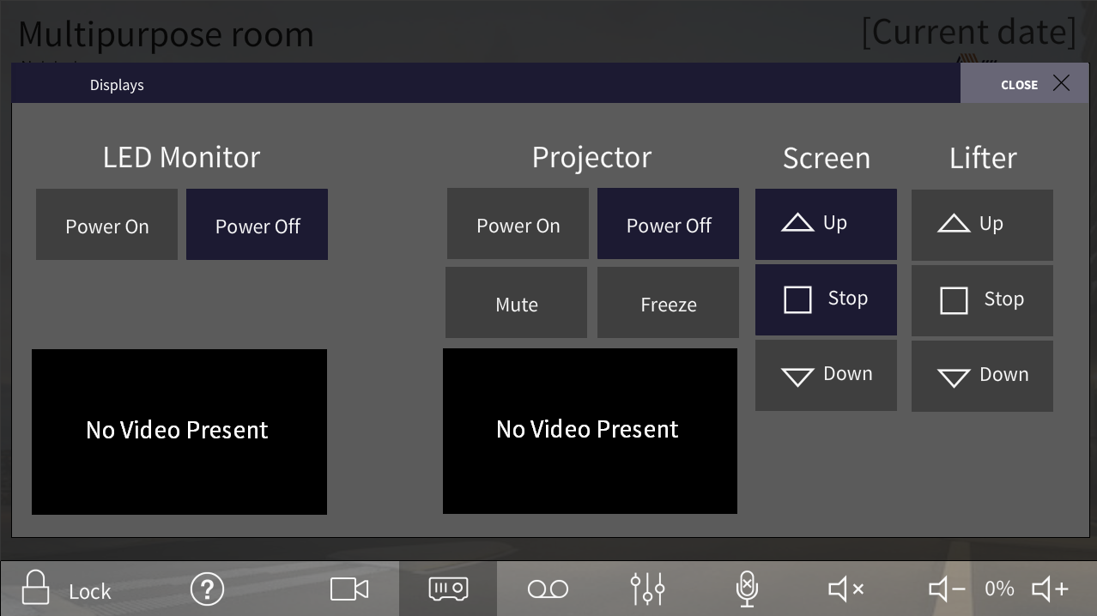

Figure 9: Display page

## Volume control

On pressing any of the volume control buttons a volume bar will appear for a few seconds to give more visual indication of the current volume.

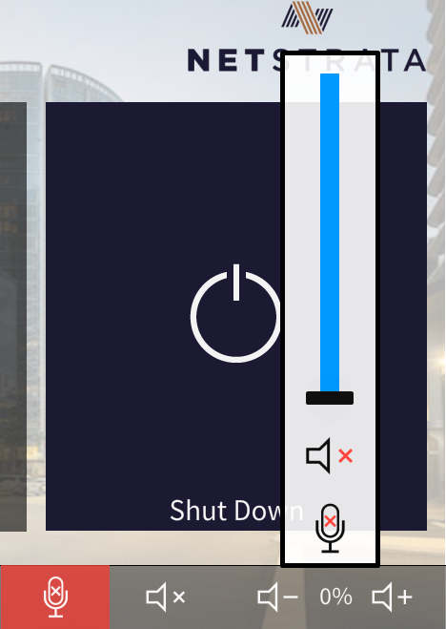

Figure 10: Volume control

# Stand-alone multi-purpose room

The stand-alone multi-purpose room will function like either of the combinable multi-purpose rooms in un-combined mode.

Figure 11: Multipurpose room presentation page

The user interface will look the same with the following exceptions:

* The initial page will be the presentation page
* There will be no link or record button.

## 10-person meeting room

The 10-person meeting room will function like the stand-alone multi-purpose room.

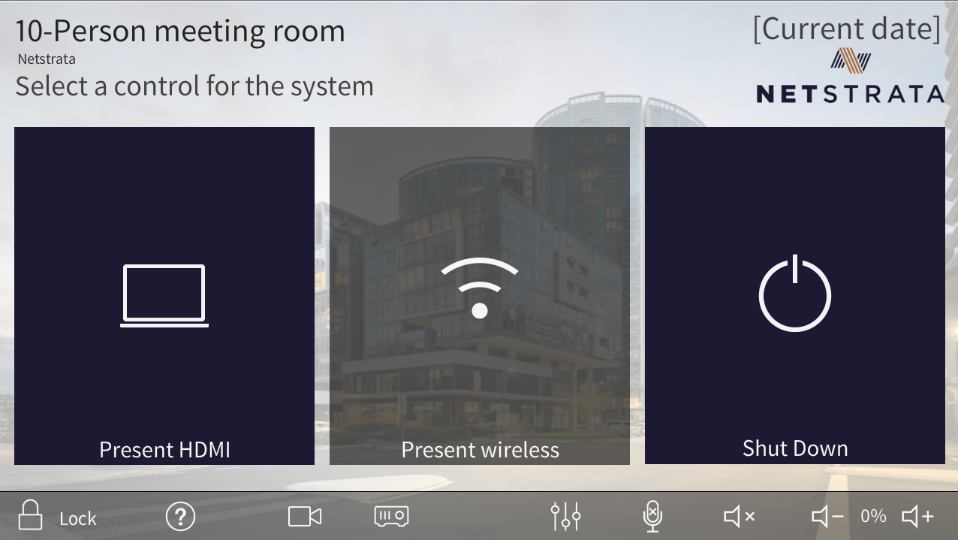

Figure 12: 10-person meeting room presentation page